**Tutorial 1**

* Using IDLE (Python's integrated development environment (IDE))
* Using the Python Shell Window
* Creating and Executing a Python Program
* Using print() and variables

1. **What is IDLE?**

IDLE is the integrated development environment (IDE) provided with Python. An IDE combines a program editor and a language environment as a convenience to the programmer. There are other IDEs that can be used to write Python programs, plus text-based programmer's editors that can be used instead of IDEs.

1. **Launching IDLE**
   1. The lab PC's have Python with IDLE. When you have logged in, click on the AppsAnywhere icon. 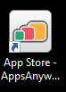
2. Then scroll down, and click on the Python icon.

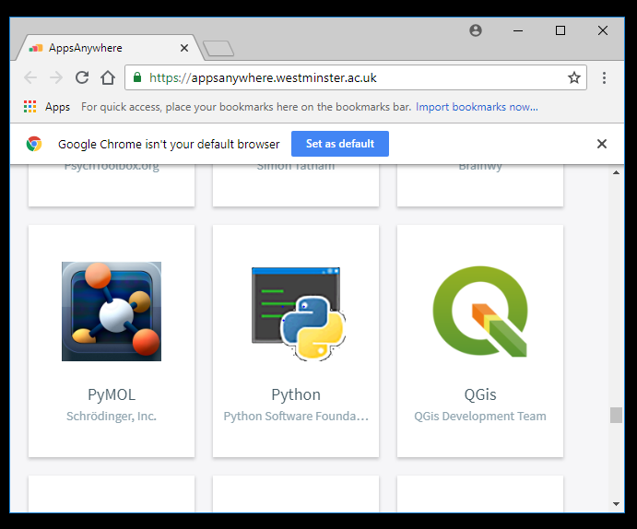

1. **Using the Python Shell Window**

When you launch Python / IDLE the Python Shell window will display and will look like this:

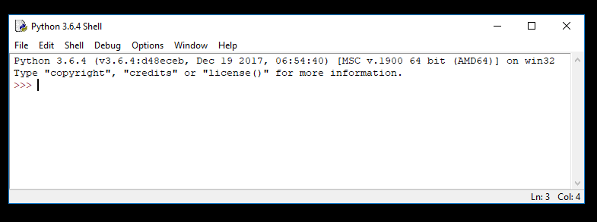

This window serves two main purposes: To let us experiment with Python commands, and to let us open a program editing window.

**Python Shell window - the last line of text in the window is the set of three 'greater-than' symbols (>>>). This is the prompt symbol.**

Click on the Python Shell window (to ensure the window has focus) and then at the prompt symbol (>>>) type this line:

>>>print(‘Hello World!’)

When you have finished typing, press the ENTER key. You should see the following:

>>> print(‘Hello World!’)

Hello World

>>>

Note that in the Python Shell window it is not necessary to use the print function to see the values.

>>> ‘Hello World!’

‘Hello World!’

>>>

However, the last example above would not work if you are running a program from a file (you would have to use the print function). Therefore, in this module **the code examples will use explicit print statements,** so that you will see the same output whether you use the examples in the Python Shell or run them from files.

1. Use the Python shell for the following.
   1. Create a variable called "course" and assign it the value "python".
   2. Create a variable called "rating" and assign it an integer value (anything you like).
   3. Print both variables to the screen using the "print" command.
2. **Creating and Executing a Python Program.** To write Python programs we need to start IDLE's editor.

a)

* From the Python Shell window, select **New File** from the **File** menu. You will see a window entitled "Untitled".

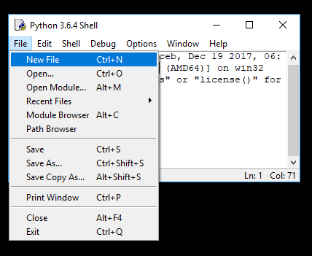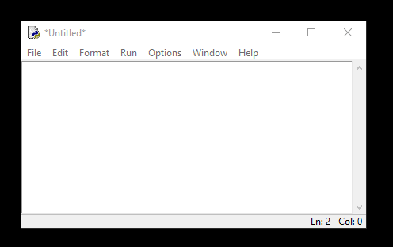

* From the **File** menu, select **Save As**, and select a folder to save your Python program file. **You need to save to your H drive.** In the **File name:** text box, type: 01-05.py. Then click on the **Save** button.
* You will then see a blank editor window ready for you to type in the following Python program.

pounds = 3

pence = pounds * 100 #answer goes to the left

print( pence ) #print answer

* To run this program, select **Run Module** from the **Run** menu. You should see a reminder to save the Source (your program). Click on OK to save. You will see your program running in a Python Shell window.

Check that the results displayed are as you expected (300). Remember, the text that follows the ‘#’ symbol is a comment that the computer ignores.

b) Replace the last line to give a better message:

print('3 pounds in pence is', pence )

c) Change a line in the program to work out 25 pounds into pence.

d) Modify the previous program to do the maths to change 5 kilometres into metres (times by 1000).

1. Type in this program, run the program and check the output.

cost = 10

postage = 2

total = cost + postage

print("Total is", total)

1. Type in the following program and see if it adds up correctly.

count = 0

count = count + 2 # add 2 on to count and store answer in count

count = count + 2

count = count + 2

count = count + 2

print("Total is", count )

1. **Exiting IDLE -** Close all Python windows to quit Python.
2. To learn more about IDLE:

* **IDLE's Own Help Information:** IDLE's menu bar has a "Help" option.
* **Information about IDLE:**  <http://docs.python.org/py3k/library/idle.html>.